**Proiect MDS**

Insane

### 

### 

**Membri echipa**

Ifrim Marius

Mihalachi Marius

Rizescu Andrei

# Cuprins

**Cuprins** **2**

**Descriere** **3**

Poveste **4**

**User stories** **5**

User story 1 5

User story 2 5

User story 3 5

User story 4 6

User story 5 6

User story 6 7

User story 7 7

User story 8 7

User story 9 7

User story 10 8

**Diagrame UML** **11**

Diagrame Clase 11

Diagrame Stari 13

Diagrame Secvente 14

Diagrame Cazuri de utilizare 15

**Source Control** **16**

**Teste automate** **17**

**Bug report** **18**

Bug 1 18

Bug 2 19

Bug 3 19

**Build Tool** **20**

**Refactoring** **21**

**Design patterns** **22**

Singleton 22

Facade 23

# 

# Descriere

Proiectul este [un joc video](https://en.wikipedia.org/wiki/Video_game#History) , pe [platforma](https://en.wikipedia.org/wiki/Video_game#Platforms) [PC](https://en.wikipedia.org/wiki/Video_game#PC) , de [gen](https://en.wikipedia.org/wiki/Video_game#Genres) [Role-playing](https://en.wikipedia.org/wiki/List_of_video_game_genres#Role-playing) , combinand aspecte de [Sandbox RPG](https://en.wikipedia.org/wiki/List_of_video_game_genres#Sandbox_RPG) si [Roguelike](https://en.wikipedia.org/wiki/Roguelike) .

Este un joc în care utilizatorul ,participantul , își asumă rolul unui personaj dintr-un univers fictiv , conceptul fiind de [Player character](https://en.wikipedia.org/wiki/Role-playing_game#Player_character) .

Momentan jocul dispune doar de varianta [Single-player](https://en.wikipedia.org/wiki/Role-playing_game#Single-player) .

Provocarile aduse de produsul nostru stau la baza termenului [Open World RPG](https://en.wikipedia.org/wiki/Open_world) . Ideea de [Sandbox](https://en.wikipedia.org/wiki/List_of_video_game_genres#Sandbox_RPG) este ca cat mai multa libertate in universul fictiv , cat si lipsa [peretilor invizibili](https://en.wikipedia.org/wiki/Invisible_wall), permitand interactiunea cu [Npcs](https://en.wikipedia.org/wiki/Non-player_character) , explorarea unei lumi cat mai vaste , insemnand mai multa alocare de timp pentru trecerea prin tot continutul jocului , povestea si universul incarcat cu provocari.

Principalele functionalitati for fi …

[dungeon crawl](https://en.wikipedia.org/wiki/Dungeon_crawl)

[procedurally generated](https://en.wikipedia.org/wiki/Procedural_generation)

[game levels](https://en.wikipedia.org/wiki/Level_(video_gaming))

[Class](https://en.wikipedia.org/wiki/Character_class)

[race](https://en.wikipedia.org/wiki/Race_(fantasy))

[High Fantasy](https://en.wikipedia.org/wiki/High_fantasy)

[Attributes](https://en.wikipedia.org/wiki/Attribute_(role-playing_games))

[skills](https://en.wikipedia.org/wiki/Skill_(role-playing_games))

Story :

|  |  |  |
| --- | --- | --- |
| A fost odata ca niciodata, intr-un regat indepartat, un rege puternic, a carui maretie era stiuta in toata lumea. Nu a existat batalie pe care acest rege sa nu o castige si de aceea celelatle regate | | |
| se temeau de el. Il considerau vrajitor, aliat al unor spirite malefice, datorita fortelor dezlantuite in timpul luptelor. Marele secret pe care celelalte regate nu il stiau, era ca regele era ajutat de un | | |
| consiliu format din 5 oameni-dragoni, alaturi de care esecul in lupta era imposibil. Insa ajutorul lor nu era gratis. Era nevoie de o suma uriasa de aur. Toate bataliile castigate pe parcursul anilor l-au facut pe rege sa fie prea sigur pe el si prea mandru, mistuit de gloria interioara. | | |
| Intr- o zi, acesta a hotarat sa distruga consiliul, considerand ca nu mai era nevoie de ei si ca pierdea prea mult aur. Fiul sau, X , s-a tot rugat de el, zile in sir, sa nu ii alunge pe cei 5, amintindu-i faptul ca sunt creaturi necunoscute omenirii si a caror putere nu are limite. Regele, biruit de propria incapatanare, nu a ascultat sfatul intelept al fiului sau si a distrus consiliul, intemnitandu-i pe cei 5 oameni-dragoni. | | |
|  |
|  |
| Anii au trecut, in regat era pace si nimeni nu indraznea sa starneasca o lupta, datorita fricii. Umbla vorba ca cei 5 ar fi murit, insa fiul regelui stia, stia ca aceasta veste nu este adevarata iar cei 5 au reusit sa scape din temnita de la capatul lumii. Acesta a pastrat secretul, pentru ca nu voia ca aceasta veste sa starneasca un razboi, unul pe care regele l-ar fi pierdut, insa, intr-o zi, la poarta castelului a aparut | | |
| o creatura. O creatura hada, cu o pelerina mai neagra decat noaptea, din care ieseau aburi si cu o gluga larga, ce ii acoperea fata. Regele, speriat de aparitia acestei creaturi, a iesit sa o intampine. Singurele vorbe pe care acea fiinta le-a spus au fost "Focul dragonilor te va parjoli". Cand regele a auzit aceste vorbe a incremenit. Erau vorbele pe care chiar el, indrumat de consiliu, le adresa inamicilor in vechile lupte. In acel | | |
| moment a stiut ca o mare primejdie il asteapta si a realizat uriasa greseala pe care a facut-o acum multi ani. Aceea de a-i alunga pe cei 5 oameni-dragoni. | | |
|  |
|  |
| 10 zile si 10 nopti a stat regele si s-a gandit cum sa isi salveze regatul de la urgia care va veni, insa nu a reusit sa gaseasca raspunsul. Intr-o zi, fiul, care era cel mai puternic luptator din tot regatul, a venit si i-a spus: | | |
| -Tata, lasa-ma pe mine sa merg si sa ii infrunt pe cei 5. | |
|  |

Regele a stat si s-a gandit foarte mult timp, dar, neavand alta solutie, l-a trimis pe fiul sau in marea lupta ce va urma.

# 

# User stories

[Github/Projects](https://github.com/ifmamaif/MDS_IMR/projects/1)

### User story 1

User Story 1: Dificultate mod de joc

Details : Ca utilizator imi doresc sa pot seta dificultatea jocului.

Type: feature

State : Done

Requester: Rizescu

Owner: Ifrim Marius

Blocker: prototipul jocului

Estimate: depinde de cat de repede este finalizat prototipul jocului

Priority: Medium

### User story 2

User Story 2: Creare personaj principal

Details: Model personaj principal ( textura, animatii )

[Utilizatorul poate modifca textura inlocuind cu alte fisiere]

Type: feature

State: Done

Requester: Rizescu

Owner: Ifrim Marius

BLocker: none

Estimate: 1 saptamana?

Priority: High

### User story 3

User Story 3 : Poveste

Details : Ca jucator vreau sa fiu introdus intr-o poveste , in universul jocului .

Type : feature

State : DONE

Requester : ifrim Marius

Owner : Rizescu , Mihalachi Marius

Blocker : --

Estimate : 3-5 zile , cel mult o saptamana

Priority : medium

### User story 4

User Story 4 : music/songs/audio effects => Background Music (first-step)

Idea : soundtrack => O melodie se repeta in fundal.

Details : Ca programator consider ca jocul ar fi monoton fara muzica de fundal , efecte sonore la anumite evenimente . Dar ca jucator m-as plictisi daca jocul nu mi-ar dispune de muzica de fundal , pierzand calitate si plictisindu-ma .Type : feature

State : DONE

Requester : Ifrim Marius

Owner : Rizescu

Blocker : ---

Estimate : o saptaman ?

Priority : medium

### User story 5

User Story 5 : Enemies problem ?

Idea : Enemies

Details : Ca develepor/programator trebuie sa intru in pielea utilizatorului pentru a face un produs de calitate , fiind utilizator si jucator la randul meu consider ca trebuie sa existe inamici ce vor ingreuna jocul si vor aduce mai multa satisfactie si distractie.Ca utilizator consider ca trebuie sa existe inamici ce vor ingreuna jocul si vor aduce mai multa satisfactie si distractie

Type : feature

State : Done

Requester : Ifrim Marius

Owner : Ifrim Marius

Blocker : prototip , finalize player

Estimate : o saptamana ?

Priority : medium

### User story 6

User Story 6: Inventory

Idea: Posibilitatea de a-ti mari inventarul . => Inventar

Details: In calitate de jucator vreau sa am o fereastra , un inventar in care sa mi se vada obiectele colectate .

Type: finished

Requester Mihalachi Marius

Owner: Ifrim Marius

Blocker: nu exista inca inventar

Estimate: 3 zile (dupa ce se face inventarul in sine)

Priority: low

### User story 7

User Story 7: Depozit  
Idea: Obiectele sa poata fi depozitate intr-un inventar secundar.  
Details: Ca jucator, nu am nevoie de toate obiectele in acelasi timp.  
Type: feature  
Requester: Mihalachi Marius  
Owner: Mihalachi Marius  
Blocker: Inventar  
Estimate:1 zi, depozitul va fi derivat din inventar  
Priority: Medium

### User story 8

User Story 8: Personalizare Caracter (grafic)

Idea: Metoda de importare/modificare a modelelor  
Details: Jucatorii sa aiba posibilitatea sa imbogateasca jocul. (Ex: minecraft - pentru un joc din cuburi, sa creezi/folosesti un skin ii da o "culoare" speciala)  
[Utilizatorul poate sa modifice texturile dupa bunul plac !]  
Type: Feature  
State : DONE  
Requester: Mihalachi Marius  
Owner: Mihalachi Marius  
Blocker: ---  
Estimate: 1 sap  
Priority: neimportant - scazut

### User story 9

User Story 9: Personalizare Caracter (gameplay)

Idea: Clase si subclase cu playstyle diferit

Details: In calitate de jucator, pentru a imi mentine interesul pentru joc, acesta are nevoie de un skill tree dezvoltat care sa iti ofere posibilitatea de a te juca din nou, fara sa fie repetitiv. Sa existe un echilibru intre clase: early-late, solo-party. Este o problema clasica: clasele de suport gasesc dificil jocul de inceput, din moment ce nu este nevoie de acestia, dar spre finalul jocului balanta s-ar schimba. Din aceasta cazua clasele de suport nu sunt populare.

State: Feature  
Requester: Mihalachi Marius  
Owner: Mihalachi Marius  
Blocker: abia avem 1 caracter  
Estimate: 1 sap + nedeterminat (un skill tree se poate dezvolta, idei sa fie)  
Priority: mediu

### User story 10

User Story 10: Meniu Principal

Details: doresc un meniu principal de unde pot porni salvarea curenta, accesa setarile, creditele etc.

Type: feature

State: DONE

Requester: Rizescu

Owner: Ifrim Marius

Blocker: prototipul jocului

Estimate: 5 zile

Priority: medium

**Print Screen Backlog facut**

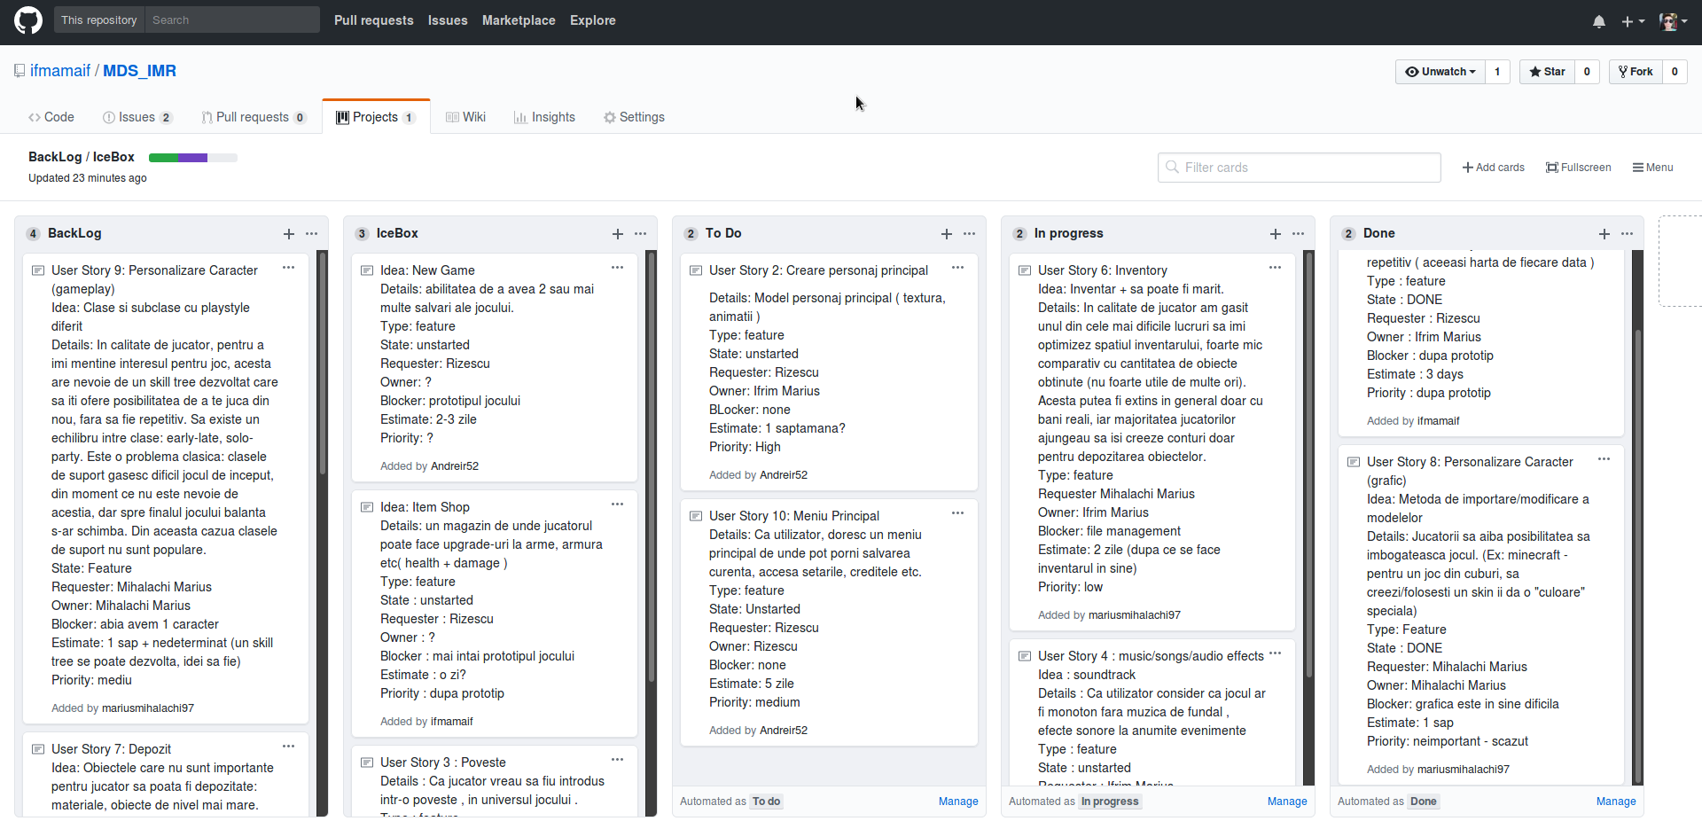

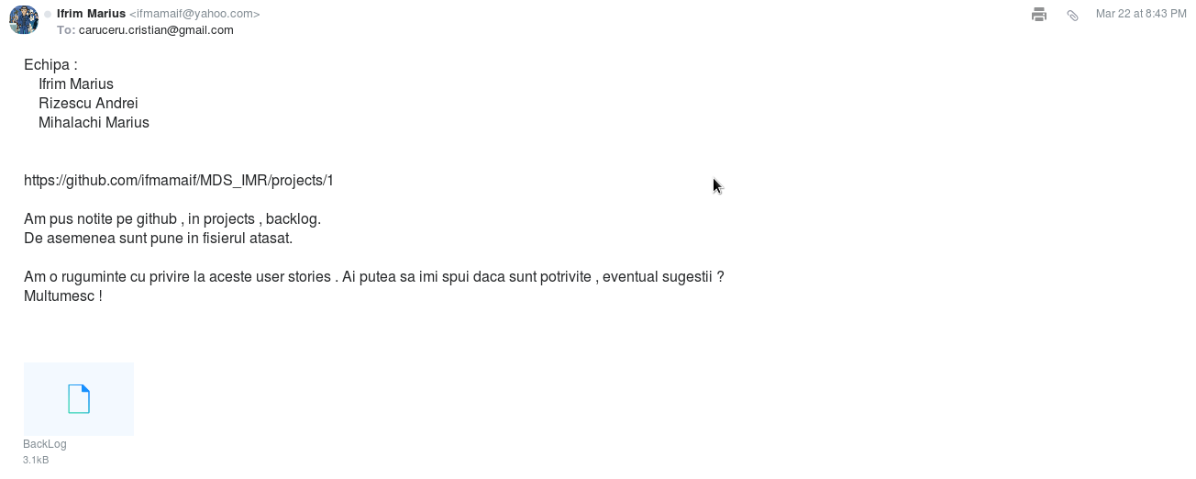

<print screen 1/3 facut>

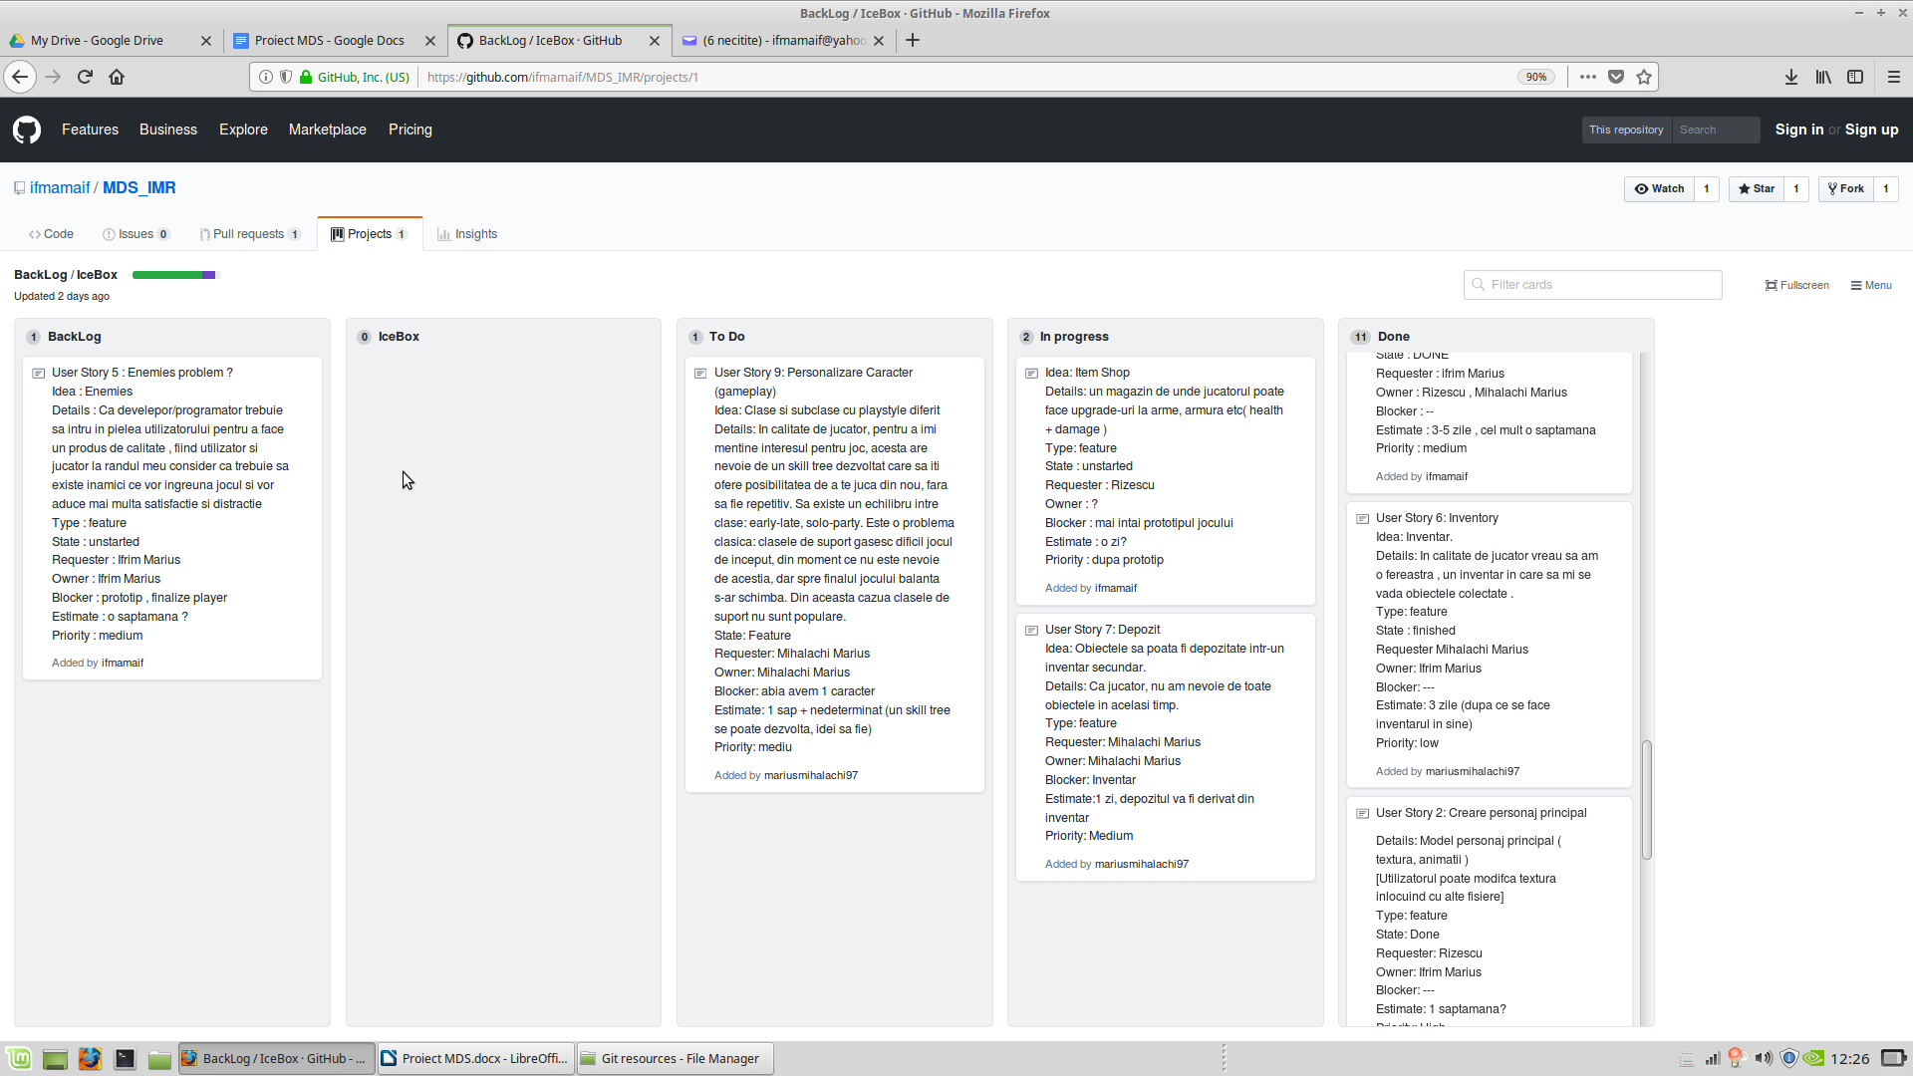<print screen final proiect>

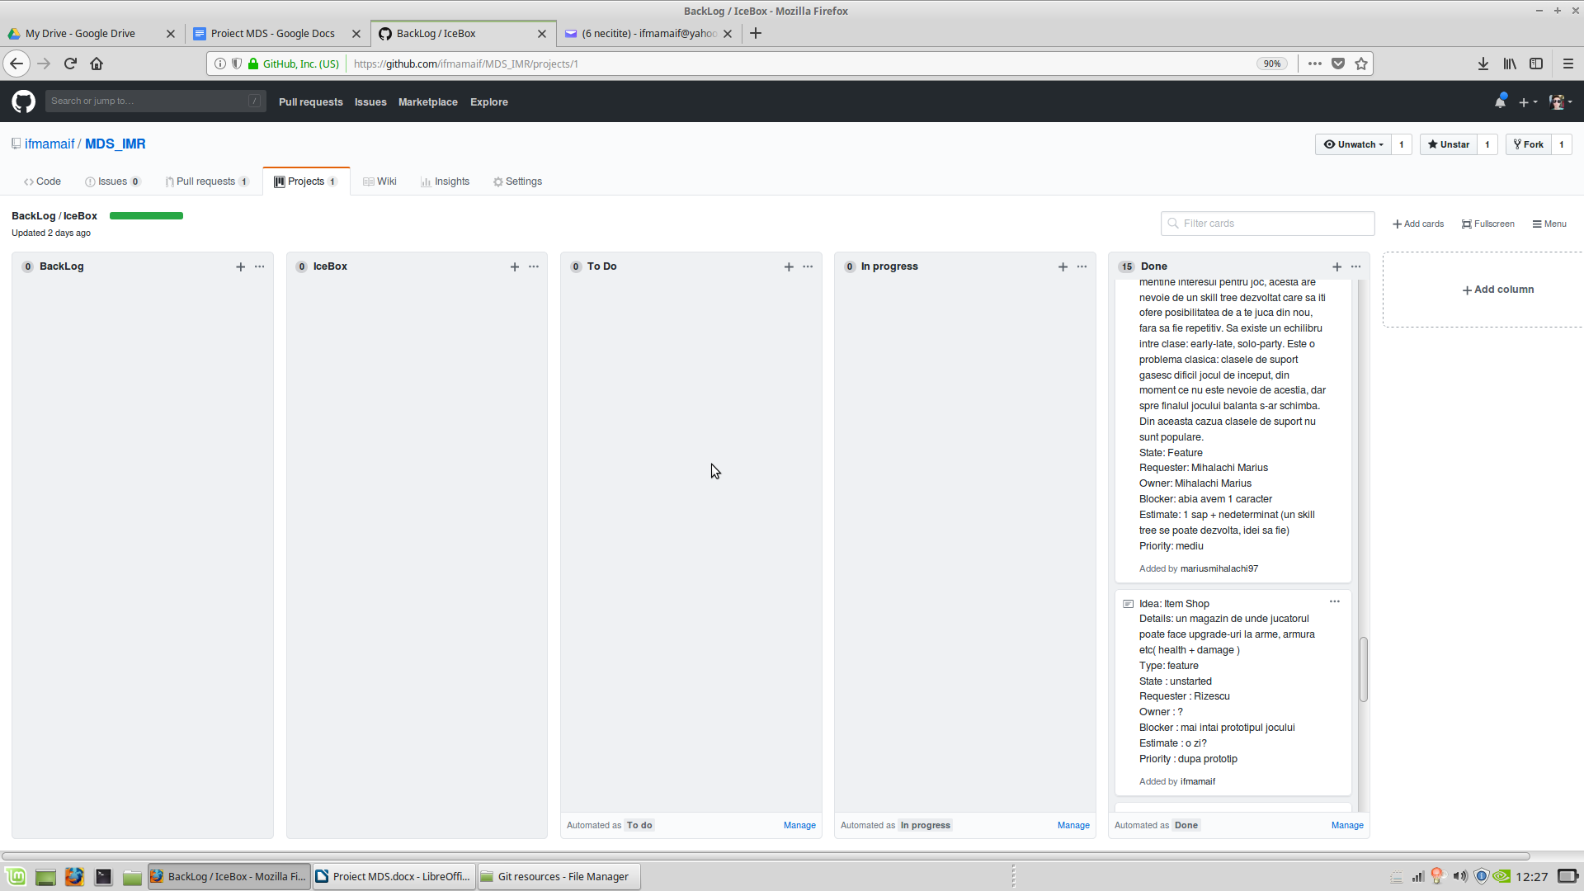

# Diagrame UML

## Diagrame Clase

GameSystem

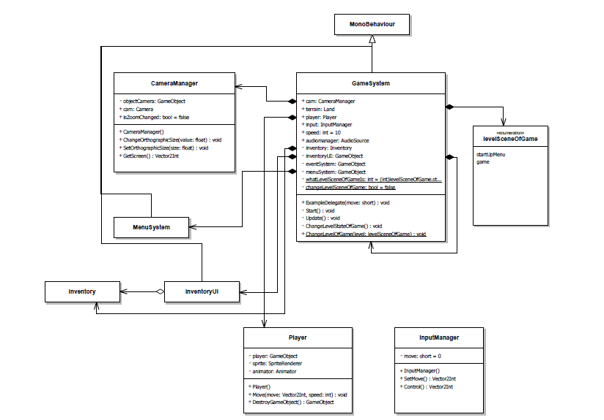

Inventory

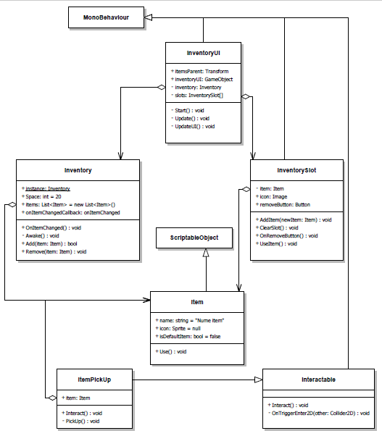

Player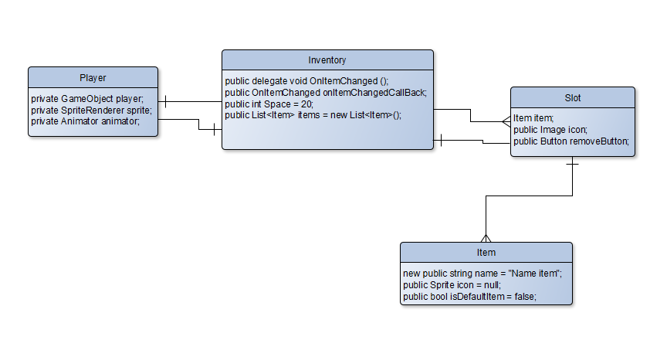

## Diagrame Stari

Start Game

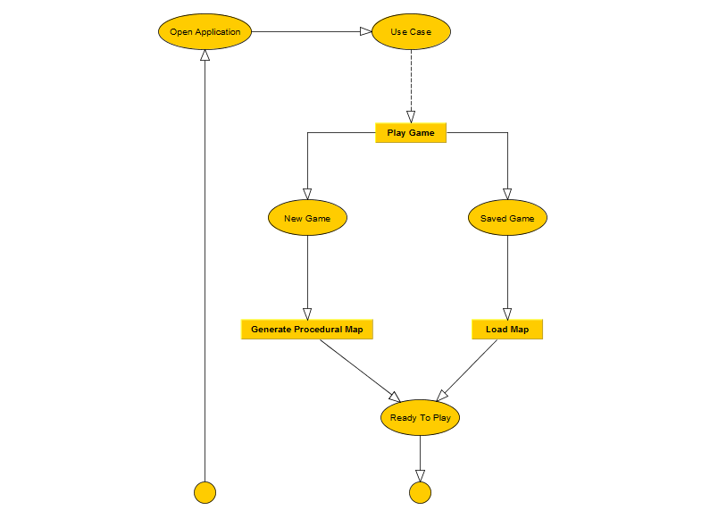

Enemy Fight

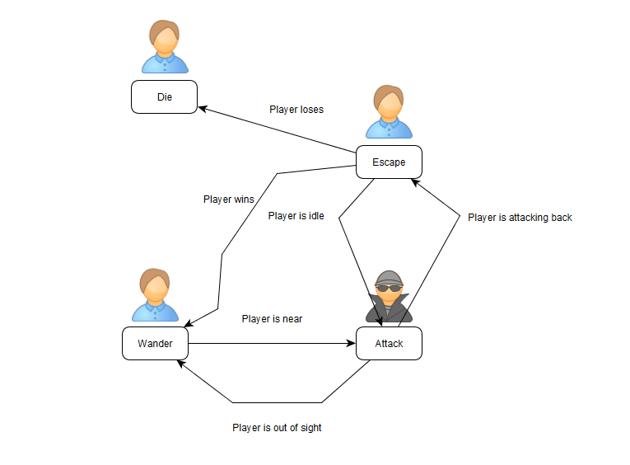

## Diagrame Secvente

Combat Sequence

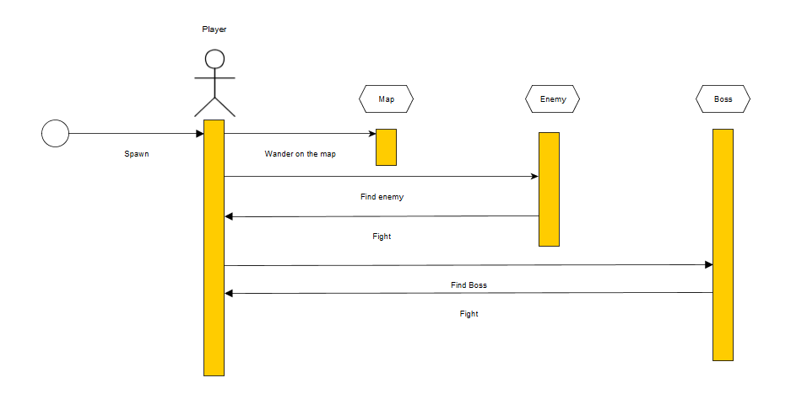

## 

## Diagrame Cazuri de utilizare

Play Game

# diagramaUseCase.png

# Source Control

### [Link Source](https://github.com/ifmamaif/MDS_IMR/) = https://github.com/ifmamaif/MDS_IMR

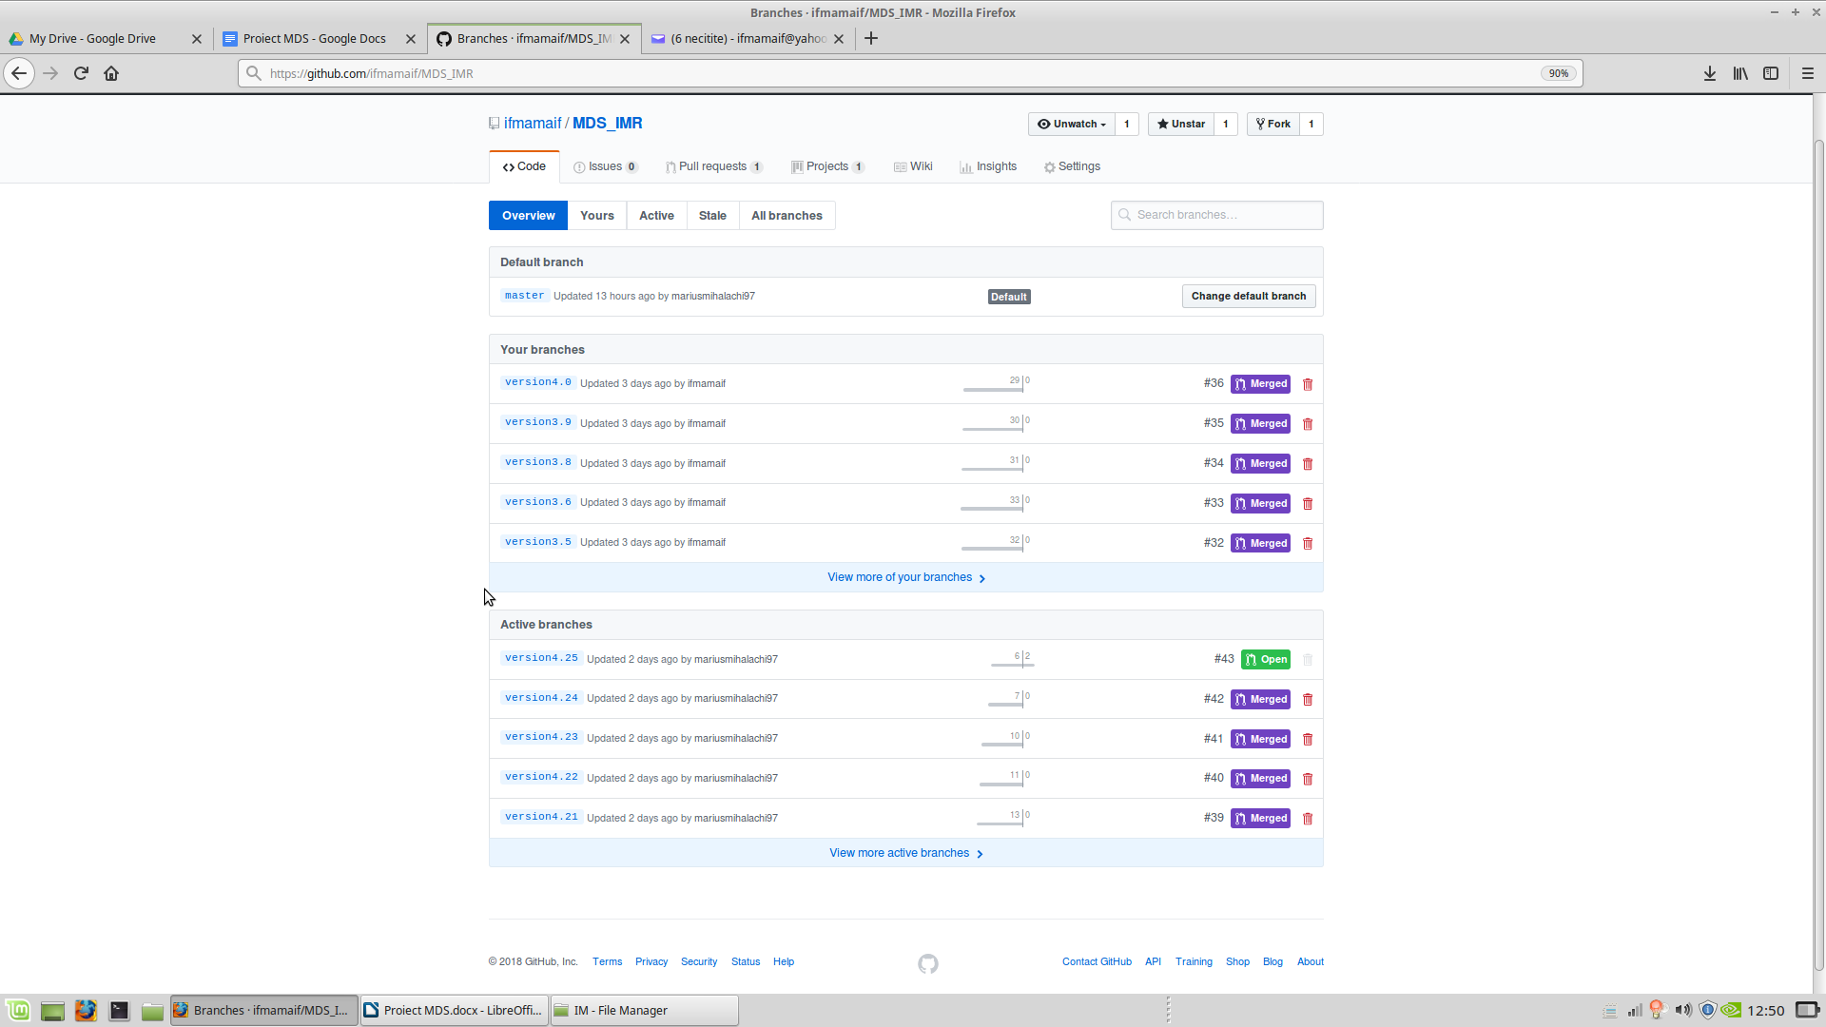

# 

# Teste automate

<copy-paste cod teste>

# 

# Bug report [[Github/Issues](https://github.com/ifmamaif/MDS_IMR/issues)]

### Bug 2

### Nume: Bug de miscare a terenului . [[Link](https://github.com/ifmamaif/MDS_IMR/issues/22)] [Rezolvat]

Descriere : Terenul consta intr-o matrice , direct proportionala cu resolutia jocului . Cand utilizatorul doreste sa miste avatarul sau , characterul va simula animatia miscare , acesta stand pe loc , iar terenul o sa fie cel care se translateaza prin modificarea pozitie primei/ultimei coloane/linii CAND avatarul intra intr-o noua celula din matrice.

Bugul consta in miscarea liniilor/coloanelor in plus , translatand terenul in exces , lasand characterul necentralizat . Mai exact prin abuzul apasarii unor 2 taste contrare de miscare in extremitatea unei celule din matrice.

### **Rezolvat**

Am inlocuit verificare indecului de miscare si de viteza cu diferenta de pozitii in spatiu .

Inainte :

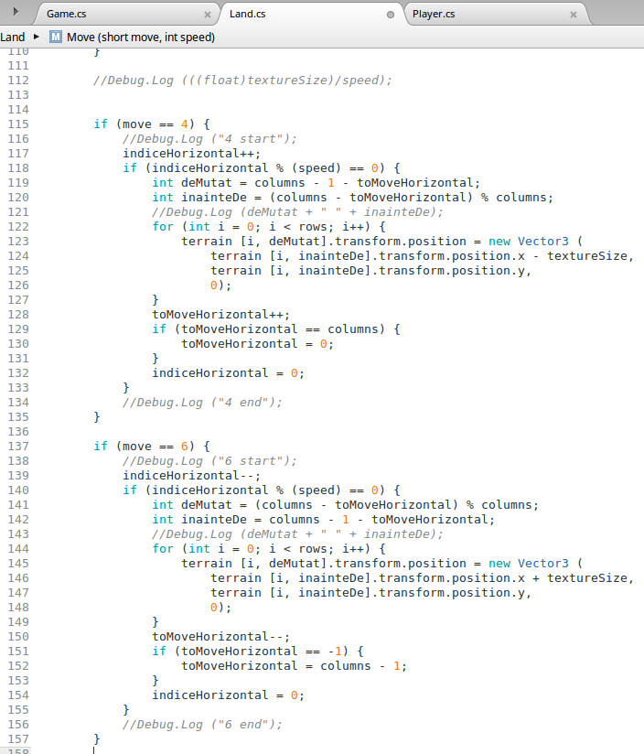

Dupa :

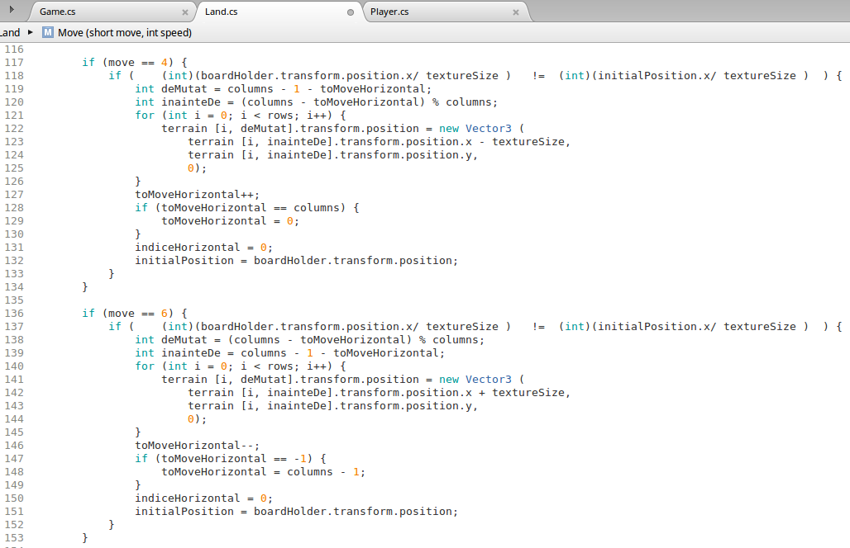

### 

### Bug 2

# Character texture bug

https://github.com/ifmamaif/MDS_IMR/issues/29

Details : When the player is moving, the texture is bugged, showing random green pixels.

Rezolvat : Am modificat textura

### Bug 3

# Bug terrain move more than expected

https://github.com/ifmamaif/MDS_IMR/issues/22

Details : Bug descoperit in timpul testarii  
Terrain-ul este o matrice .  
Miscare "vizuala" se efectuaza translatand coloane sau linii (prima sau ultima).  
Cand avatarul trece in alta celula din matrice se apeleaza translatarea coloanei sau liniei .  
Bugul consta in translatarea excesiva a coloanelor sau liniilor cand avatarul este la limita dintre celule si efectueaza multe apeluri catre "miscarea terenului"

Rezolvat : Rezolvat  
Verificari si comparari de indici de miscare si viteza =>Verificari si comparati intre pozitii in spatiu

# Build Tool

Am folosit build tool-ul integrat din Unity.

# 

# Refactoring

<copy/paste cod inainte de refactoring>

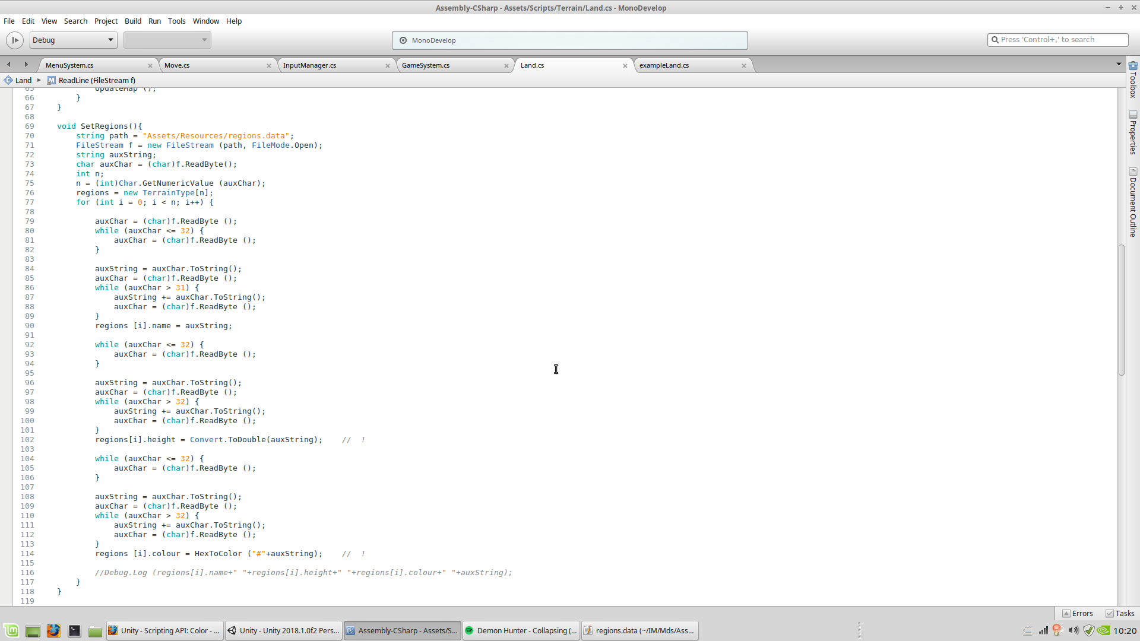

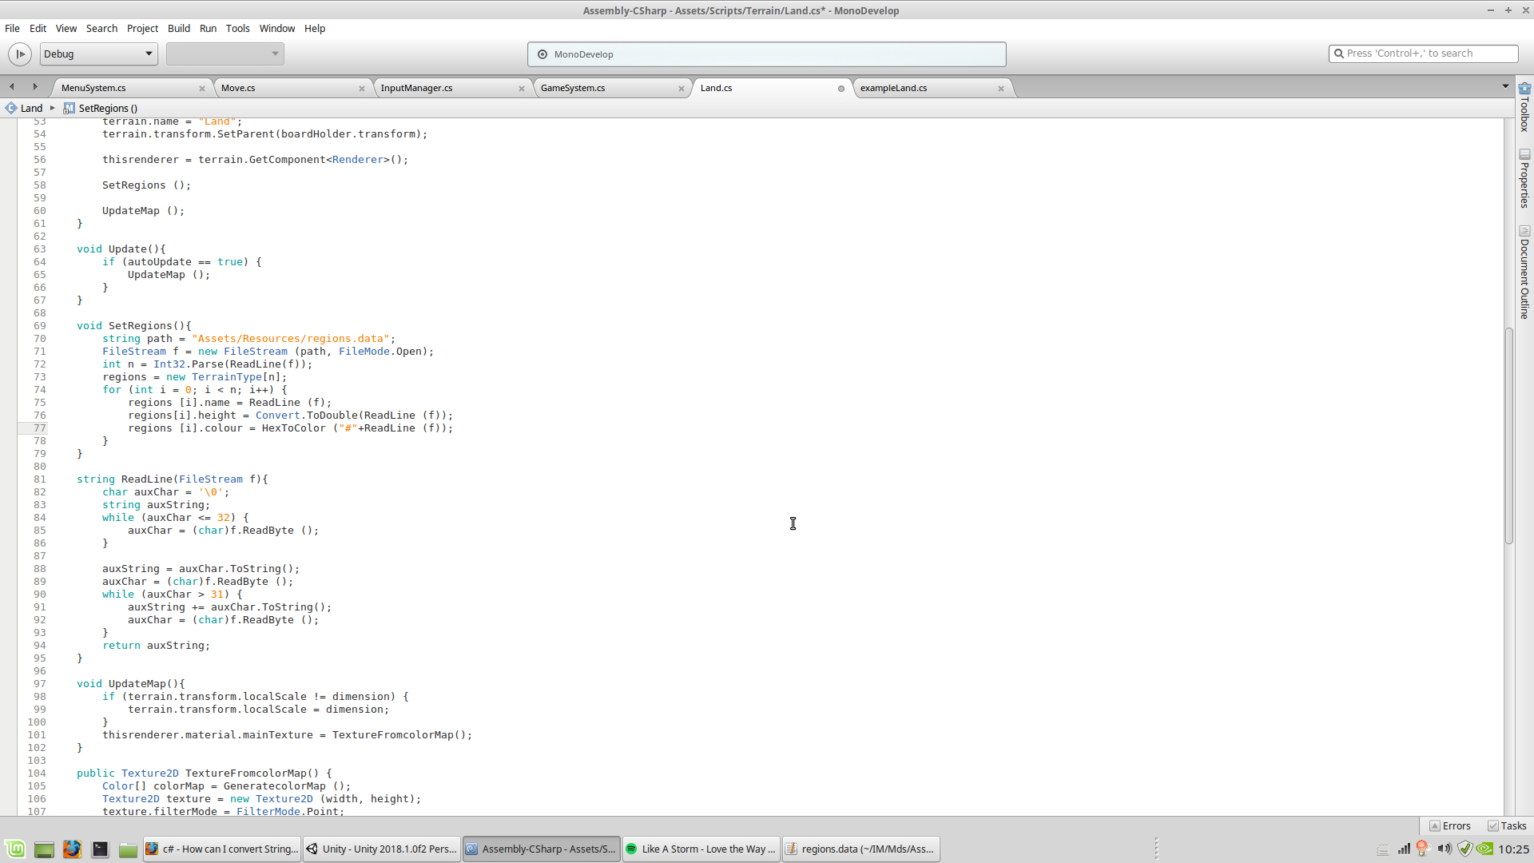<copy/paste cod dupa refactoring>

Se evita redundanta codului.

# Design patterns

### Singleton

public class Inventory {

#region

public static Inventory instance;

void Awake(){ // derivated from MonoBehaviour script;

if (instance != null) {

Debug.LogWarning ("More instance of inventory!");

return;

}

Debug.Log ("daaaaa");

instance = this;

}

#endregion

public Inventory(){

if (instance != null) {

Debug.LogWarning ("More instance of inventory!");

return;

}

instance = this;

}

public delegate void OnItemChanged ();

OnItepublicmChanged onItemChangedCallBack;

public int Space = 20;

public List<Item> items = new List<Item>();

public bool Add(Item item){

if(!item.isDefaultItem){

if (items.Count >= Space) {

Debug.Log ("Not enough space in inventory!");

return false;

}

items.Add(item);

if(onItemChangedCallBack != null)

onItemChangedCallBack.Invoke ();

//return true;

}

return true;

}

public void Remove(Item item){

items.Remove(item);

if(onItemChangedCallBack != null)

onItemChangedCallBack.Invoke ();

}

public void DestroyGameObject(){

items.Clear ();

}

}

### Facade

public class MenuSystem : MonoBehaviour {

public GameObject mainMenu;

public GameObject newGame;

public GameObject savedGames;

public GameObject exitMessage;

public GameObject newCharacter;

public GameObject alertMessage;

public GameObject settings;

private bool isHardMode = false;

public Button normalDifficultyButton;

public Button hardDifficultyButton;

public GameObject nameCharacterInputField;

private bool isVisibleSavedGames = false;

private Vector2 scrollViewVector = Vector2.zero;

private Vector2 guiDimension = new Vector2(410,340);

private float longlist = 0;

public GameObject soundButton;

private bool isSoundMuted = false;

private string[] listSavedGames;

private string whatSavedGame="";

public Text textLoadButton;

// Use this for initialization

void Start () {

mainMenu.SetActive (true);

exitMessage.SetActive (false);

newGame.SetActive (false);

newCharacter.SetActive (false);

alertMessage.SetActive (false);

settings.SetActive (false);

savedGames.SetActive (false);

isVisibleSavedGames = false;

}

void OnGUI(){

if (isVisibleSavedGames == true) {

// Begin the ScrollView

scrollViewVector = GUI.BeginScrollView (new Rect (Screen.width / 2 - guiDimension.x / 2, Screen.height / 2 - guiDimension.y / 2, guiDimension.x, guiDimension.y), scrollViewVector, new Rect (0, 0, 0, longlist));

GUI.BeginGroup (new Rect (0, 0, guiDimension.x, longlist)); // Bottom right group of buttons

int k=0;

for (int i = 0; i < listSavedGames.Length; i++) {

string textSavedGame = Filter (listSavedGames[i]);

if (textSavedGame == ".") {

k++;

} else if (textSavedGame == "..") {

k++;

} else {

if (GUI.Button (new Rect (0, ((i - k) * 60) + ((i - k) * 10), guiDimension.x - 90, 60), textSavedGame)) {

//Debug.Log ("You pressed " + textSavedGame);

whatSavedGame = textSavedGame;

textLoadButton.text = "Load " + whatSavedGame;

}

if (GUI.Button (new Rect (guiDimension.x - 80, ((i - k) * 60) + ((i - k) * 10), 50, 60), "X")) {

//Debug.Log ("You delete " + textSavedGame);

File.Delete(listSavedGames[i]);

File.Delete(listSavedGames[i]+".meta");

textLoadButton.text = "Load";

whatSavedGame = "";

UpdateSavedGames ();

}

}

}

GUI.EndGroup ();

GUI.EndScrollView (); // End the ScrollView

}

}

public void BackToMainMenuFromExit(){

mainMenu.transform.localPosition= new Vector3 (0, 0, 0);

mainMenu.SetActive (true);

exitMessage.SetActive (false);

}

public void ToExitGame(){

exitMessage.transform.localPosition= new Vector3 (0, 0, 0);

mainMenu.SetActive (false);

exitMessage.SetActive (true);

}

public void GooGoodBye(){

Application.Quit ();

}

public void BackToMainMenuFromNewGame(){

mainMenu.transform.localPosition= new Vector3 (0, 0, 0);

mainMenu.SetActive (true);

newGame.SetActive (false);

}

public void ToNewGame(){

newGame.transform.localPosition= new Vector3 (0, 0, 0);

mainMenu.SetActive (false);

newGame.SetActive (true);

}

public void BackToMainMenuFromNewCharacter(){

mainMenu.transform.localPosition= new Vector3 (0, 0, 0);

mainMenu.SetActive (true);

newCharacter.SetActive (false);

}

public void ToNewCharacter(){

newCharacter.transform.localPosition= new Vector3 (0, 0, 0);

newGame.SetActive (false);

newCharacter.SetActive (true);

}

public void BackToNewCharacter(){

alertMessage.SetActive (false);

newCharacter.SetActive (true);

}

public void NewStart(){

string name = nameCharacterInputField.GetComponent<InputField> ().text;

if (IsValidNameCharacter (name) == true) {

string path = "Assets/Resources/Saved/" + name + ".data";

if (File.Exists (path) == false) {

FileStream f = new FileStream (path, FileMode.CreateNew);

int offSetX = UnityEngine.Random.Range (-99999, 99999);

Debug.Log ("Random X : " + offSetX);

byte[] byteArray = BitConverter.GetBytes (offSetX);

f.Write (byteArray, 0, byteArray.Length);

int offSetY = UnityEngine.Random.Range (-99999, 99999);

Debug.Log ("Random Y : " + offSetY);

byteArray = BitConverter.GetBytes (offSetY);

f.Write (byteArray, 0, byteArray.Length);

byteArray = System.Text.Encoding.UTF8.GetBytes (name);

f.Write (byteArray, 0, byteArray.Length);

byteArray [0] = (byte)(isHardMode == true ? 1 : 0);

f.WriteByte (byteArray [0]);

f.Close ();

//Debug.Log (name + " Character Saved!");

path = "Assets/Resources/Config/whatToPlay.cfg";

f = new FileStream (path, FileMode.Create);

byte[] data = new byte[name.Length];

for (int i = 0; i < name.Length; i++) {

data [i] = (byte)name [i];

//Debug.Log (name [i]+" "+data[i]);

}

f.Write (data, 0, data.Length);

f.Close ();

GameSystem.ChangeLevelOfGame (GameSystem.levelSceneOfGame.game);

} else {

alertMessage.transform.localPosition = new Vector3 (0, 0, 0);

newCharacter.SetActive (false);

alertMessage.SetActive (true);

}

}

}

public static bool IsValidNameCharacter(string text){

for (int i = 0; i < text.Length; i++) {

if (text [i] < '0' || text [i] > '9')

if (text [i] < 'a' || text [i] > 'z')

if (text [i] < 'A' || text [i] > 'Z')

return false;

}

return true;

}

public void ToSavedGames(){

savedGames.transform.localPosition = new Vector3 (0, 0, 0);

mainMenu.SetActive (false);

savedGames.SetActive (true);

listSavedGames = Directory.GetFiles(Application.dataPath+ "/Resources/Saved","*.data");

int dimensiune = listSavedGames.Length *70;

if (dimensiune > guiDimension.y) {

longlist = dimensiune + 10;

} else {

longlist = guiDimension.y;

}

isVisibleSavedGames = true;

}

public void UpdateSavedGames(){

listSavedGames = Directory.GetFiles (Application.dataPath + "/Resources/Saved", "*.data");

int dimensiune = listSavedGames.Length * 70;

if (dimensiune > guiDimension.y) {

longlist = dimensiune + 10;

} else {

longlist = guiDimension.y;

}

}

public void BackToMainMenuFromSavedGames(){

isVisibleSavedGames = false;

savedGames.SetActive (false);

mainMenu.SetActive (true);

}

string Filter(string stringSource){

int positionLastSlash = 0;

int positionDot =0;

for (int i = 0; i < stringSource.Length; i++) {

if (stringSource [i] == '/')

positionLastSlash = i+1;

else if (stringSource [i] == '.')

positionDot = i;

}

string result = new string (stringSource [positionLastSlash], 1);

for(int i=positionLastSlash+1;i<positionDot;i++){

result += stringSource[i];

}

return result;

}

public void SoundVolume(){

if (isSoundMuted == false) {

isSoundMuted = true;

soundButton.GetComponent<Image>().overrideSprite = Resources.Load<Sprite> ("Sprites/UI/1");

} else {

isSoundMuted = false;

soundButton.GetComponent<Image>().overrideSprite = Resources.Load<Sprite> ("Sprites/UI/0");

}

}

public void BackToMainMenuFromSettings(){

mainMenu.SetActive (true);

settings.SetActive (false);

}

public void ToSettings(){

settings.transform.localPosition= new Vector3 (0, 0, 0);

mainMenu.SetActive (false);

settings.SetActive (true);

}

public void LoadSavedGame(){

if (whatSavedGame != "") {

string path = "Assets/Resources/Config/whatToPlay.cfg";

FileStream f = new FileStream (path, FileMode.Create);

byte[] data = new byte[whatSavedGame.Length];

for (int i = 0; i < whatSavedGame.Length; i++) {

data [i] = (byte)whatSavedGame [i];

}

f.Write (data, 0, data.Length);

f.Close ();

GameSystem.ChangeLevelOfGame (GameSystem.levelSceneOfGame.game);

}

}

public void SetToNormalDifficulty(){

isHardMode = false;

normalDifficultyButton.interactable = false;

hardDifficultyButton.interactable = true;

}

public void SetToHardDifficulty(){

isHardMode = true;

normalDifficultyButton.interactable = true;

hardDifficultyButton.interactable = false;

}

}

public class GameSystem : MonoBehaviour {

public CameraManager cam;

public Land terrain;

public Player player;

public InputManager input;

public int speed = 10;

public delegate void ExampleDelegate (short move);

public AudioSource audiomanager;

private Inventory inventory;

private GameObject inventoryUI;

private GameObject eventSystem;

private GameObject menuSystem;

public enum levelSceneOfGame{

startUpMenu,

game

};

private static int whatLevelSceneOfGameIs = (int)levelSceneOfGame.startUpMenu;

private static bool changeLevelSceneOfGame = false;

void Start () {

cam = new CameraManager ();

menuSystem = (GameObject)Instantiate(Resources.Load("Prefabs/MenuSystem",typeof(GameObject)));

menuSystem.name = "MenuSystem";

eventSystem = new GameObject ("EventSystem");

eventSystem.AddComponent<EventSystem>();

eventSystem.AddComponent<StandaloneInputModule> ();

input = new InputManager();

/*

gameObject.AddComponent<AudioSource> ();

audiomanager = gameObject.GetComponent<AudioSource> ();

audiomanager.clip = Resources.Load<AudioClip> ("Audio/Dynasty Wars - Shinyang Castle (round 7)");

audiomanager.Play ();

audiomanager.loop = true;

audiomanager.enabled = false; // !! keep it true for testing or release . !!

*/

/*

Vector2Int backScreen = (Vector2Int)cam.GetScreen ();

terrain = new Land (backScreen);

player = new Player ();

Inventory inventory = new Inventory ();

inventory.Space = 20;

inventoryUI = (GameObject)Instantiate(Resources.Load("Prefabs/InventoryUI",typeof(GameObject)));

inventoryUI.name = "InventoryUI";

*/

}

// Update is called once per frame

void Update () {

if (changeLevelSceneOfGame == true) {

ChangeLevelStateOfGame ();

changeLevelSceneOfGame = false;

} else if (whatLevelSceneOfGameIs == (int)levelSceneOfGame.game) {

if (Input.anyKey == true) {

Vector2Int move = input.Control ();

terrain.Move (move, speed);

player.Move (move, speed);

if (Input.GetKeyDown (KeyCode.Escape)) {

menuSystem.SetActive (!menuSystem.activeSelf);

}

} else {

player.Move (new Vector2Int (0, 0), speed);

}

}

}

void ChangeLevelStateOfGame(){

if (whatLevelSceneOfGameIs == (int)levelSceneOfGame.game) {

menuSystem.SetActive (false);

Vector2Int backScreen = (Vector2Int)cam.GetScreen ();

terrain = new Land (backScreen);

player = new Player ();

Inventory inventory = new Inventory ();

inventory.Space = 20;

inventoryUI = (GameObject)Instantiate (Resources.Load ("Prefabs/InventoryUI", typeof(GameObject)));

inventoryUI.name = "InventoryUI";

} else {

menuSystem.SetActive (true);

Destroy (terrain.DestroyGameObject());

Destroy (player.DestroyGameObject());

inventory.DestroyGameObject();

Destroy (inventoryUI);

}

}

public static void ChangeLevelOfGame(levelSceneOfGame level){

whatLevelSceneOfGameIs = (int)level;

changeLevelSceneOfGame = true;

}

}